Kieran Burrell
Student Number: 23893036
coursework 2
CIS4118 – Data Visualisation

Contents
Introduction 2
Data Description 3
Background Research 4
Implementation 5
Imports 5
Importing and Formatting Datasets 6
Console Output 8
Dataset Exploration 9
Console Output 10
Plot 11
Activity Exploration 12
Console Output 14
Plots 15
Participant Exploration 16
Console Output 20
Plots 22
Evaluation 25
References 26

Introduction
This coursework aims to produce a piece of software for the interactive visualisation of multivariate time-series data involving human activities. This problem has relevance to the expanding world of human activity/behaviour monitoring for elderly people, as well as patients undergoing rehabilitation. This would automate the process of visualising daily activity patterns and routines, which could help in designing and supporting personalised care, health and safety, medical emergency, personalized rehabilitation as well as precision medicines.
The objectives of this coursework are to:
- Systematically analyse and evaluate various data analytics methods, and statistical modelling techniques and adapt them to real-world problems in social, business and/or scientific domains.
- Develop a holistic research-based road-map to analyse, design and build a visualisation system using emerging tools and technologies for an identified problem (business, scientific and/or social)
Each of the objectives must be shown throughout the report.

Data Description
Human Activities and Postural Transitions (HAPT) Dataset is publicly available and can be downloaded from the UCI Machine learning repository [1]. The dataset is created with a group of 30 volunteers within an age bracket of 19-48 years. They performed a protocol of activities composed of six basic activities: three static postures (standing, sitting, lying) and three dynamic activities (walking, walking downstairs and walking upstairs). The experiment also included postural transitions that occurred between the static postures. These are stand-to-sit, sit-to-stand, sit-to-lie, lie-to-sit, stand-to-lie, and lie-to-stand. All the participants were wearing a smartphone (Samsung Galaxy S II) on their waist during the experiment execution. Each data sample consists of 3-axial linear acceleration and 3-axial angular velocity at a constant rate of 50Hz using the embedded accelerometer and gyroscope of the device. The experiments were video-recorded to label the data manually. The obtained dataset was randomly partitioned into two sets, where 70% of the volunteers were selected for generating the training data and 30% for the test data.
The sensor signals (accelerometer and gyroscope) were pre-processed by applying noise filters and then sampled in fixed-width sliding windows of 2.56 sec and 50% overlap (128 readings/window). The sensor acceleration signal, which has gravitational and body motion components, was separated using a Butterworth low-pass filter into body acceleration and gravity. The gravitational force is assumed to have only low-frequency components, therefore a filter with a 0.3 Hz cut-off frequency was used. From each window, a vector of 561 features was obtained by calculating variables from the time and frequency domain.

Background Research
Human Activity Recognition is an active field of research that aims to understand human behaviour through the interpretation of sensory information gathered from people and the environment they live in. This enables context awareness, which allows the emergence of more interactive and cognitive environments [2], [3]. As shown by the dataset, one method of obtaining user-related activity information is through smartphone sensors. The accelerometer and gyroscope sensors in the smartphone are capable of collecting data for used for activity detection. As is the common theme with big data datasets, the dataset has a large volume of data and a variety of features to analyse. When visualising the datasets of this size, they are considered to have high dimensional space which can be difficult to visualise.
Dimensionality Reduction is the process of reducing the number of features to the most relevant ones reducing some information while allowing the data to be visualised in a 2d or 3d space. Principal Component Analysis (PCA) and T-distributed Stochastic Neighbour Embedding (T-SNE) are both techniques for reducing the number of dimensions in a dataset. PCA is a fast and flexible unsupervised method for linear dimensionality reduction using Singular Value Decomposition of the data to project it to a lower-dimensional space. Because of the versatility and interpretability of PCA, it can be effective in a wide variety of contexts and disciplines. PCA's main weakness is that it tends to be highly affected by outliers in the data. For this reason, many robust variants of PCA have been developed in the sklearn library [4]. T-SNE is a tool to visualise high-dimensional data. It converts similarities between data points to joint probabilities and tries to minimise the Kullback-Leibler divergence between the joint probabilities of the low-dimensional embedding and the high-dimensional data [5], [6].
Aspects of the program use a LightGBM classifier to determine the accuracy and importance of the data. LightGBM is a gradient boosting framework that uses tree-based learning algorithms. It is designed to be distributed and efficient with the following advantages [7]:
- Faster training speed and higher efficiency.
- Lower memory usage.
- Better accuracy.
- Support parallel and GPU learning.
- Capable of handling large-scale data.

Implementation

Imports
To start the program several library imports are made for the program to work as intended. This includes some popular modules such as the NumPy and Pandas library used for handling large and multidimensional arrays and data manipulation and analysis respectively. As for the graphical representations shown in the solution, the Matplotlib, Seaborn and Plotly libraries are used for creating a variety of plots and several other data visualisation tools. Along with some obscurer libraries such as the Collections library used to obtain the counter, Scipy library for scientific computing used to get the tools needed for visualising distribution, sklearn library for predictive data analysis used to create models and import the PCA and T-SNE components required for some of the visualisations, and finally the lightgbm library providing some basic framework for machine learning classification.
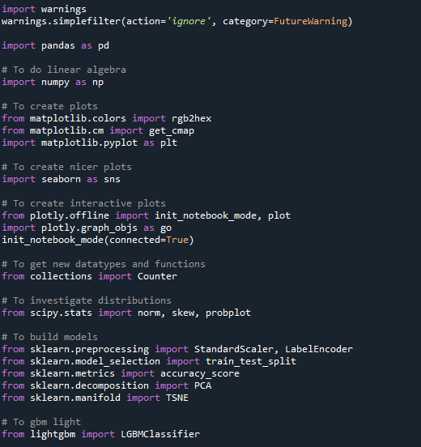

Importing and Formatting Datasets
The dataset provided includes several different files each an aspect of the dataset. These include:
- 'features.txt': List of all features.
- 'activity_labels.txt': Links the activity ID with their activity name.
- 'Train/X_train.txt': Training set.
- 'Train/y_train.txt': Training labels.
- 'Test/X_test.txt': Test set.
- 'Test/y_test.txt': Test labels.
- 'Train/subject_id_train.txt': Each row identifies the subject who performed the activity for each window sample. Its range is from 1 to 30.
- 'Test/subject_id_test.txt': Each row identifies the subject who performed the activity for each window sample. Its range is from 1 to 30.
To begin this section, the features and train and test sets are read in the program and stored in the feature_list, train_df, and test_df respectively. The column headers of each data frame are then added by passing the feature_list. Next, the subject IDs for both the train and test sets are accessed from the dataset files and stored in a list data structure before being added as a new column to both data frames.
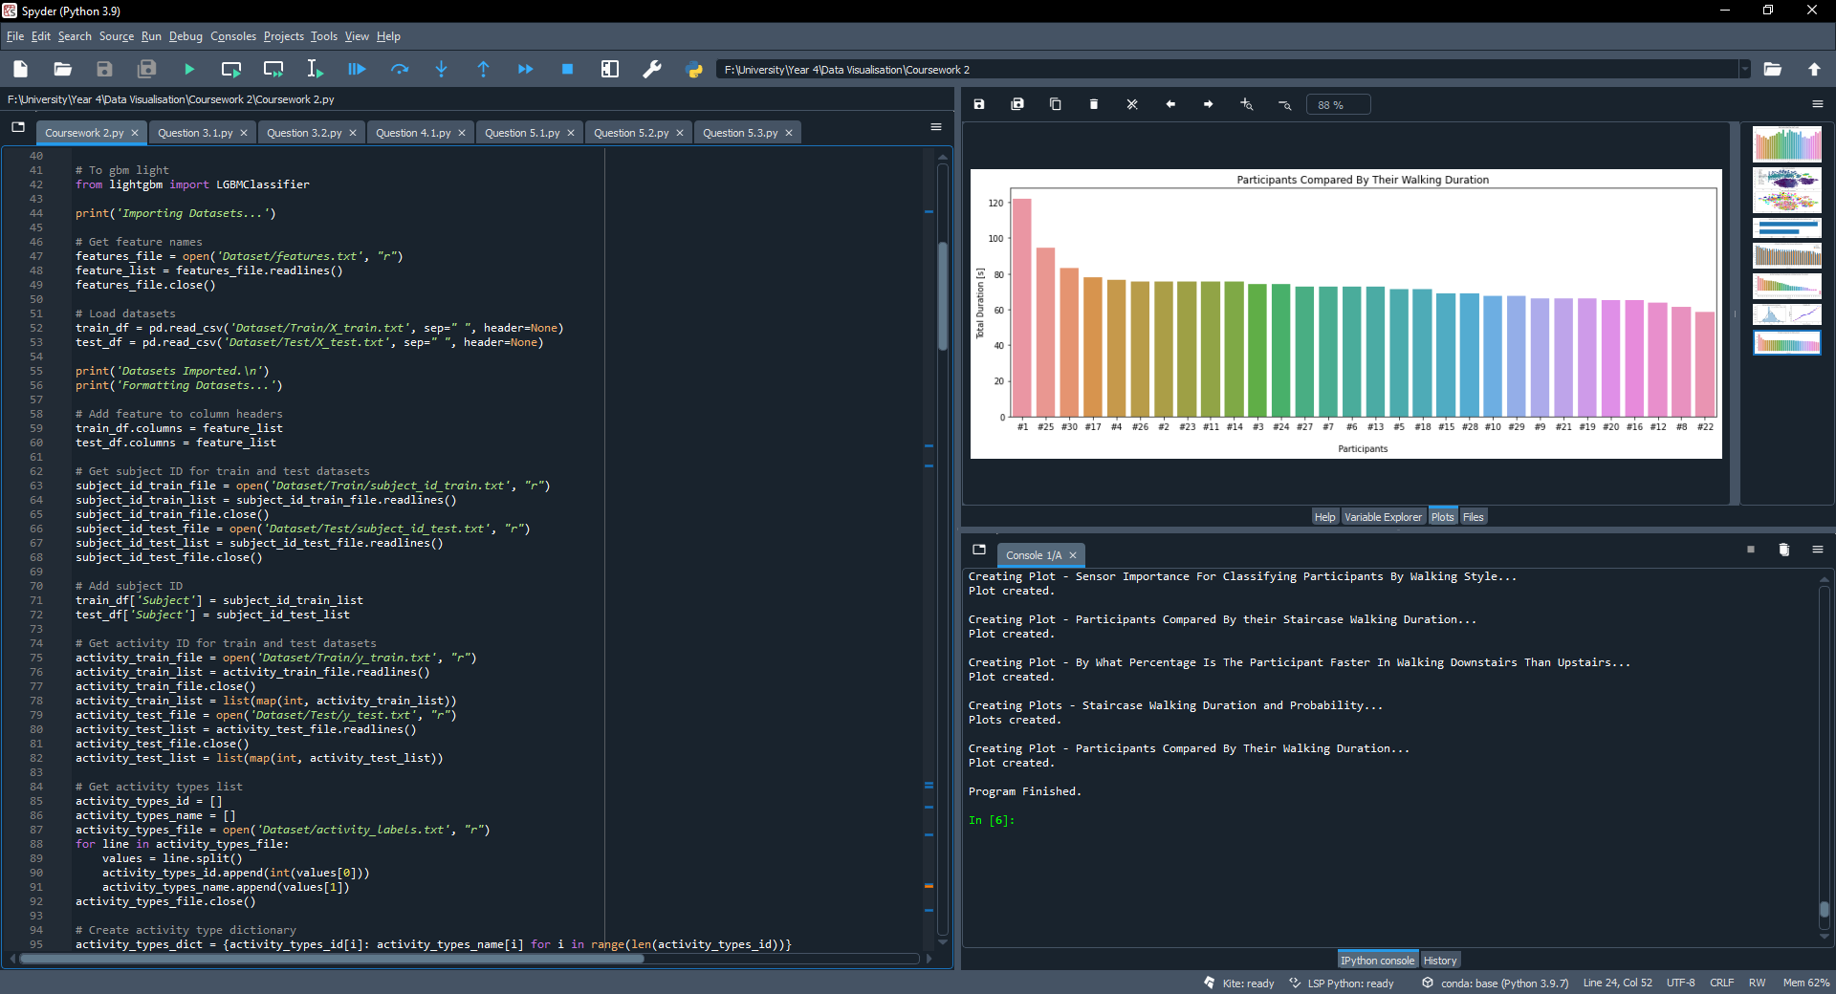

The train and test activity labels are then read into the program with each label being passed through the map function to assure each item is an integer. Next, the string value of the activity type is obtained from the activity_labels.txt file. This section split each line within the value to separate the integer and string values of the activities, storing them in separate lists.
A dictionary is created storing and mapping each of the activity type id and name lists together before being used to convert each of the numerical values of the train and test activity type into the string value of the activity, this was done to improve the understanding of the data when being plotted. Each of the converted lists is then added to the data frames along with the column header ‘Activity’. To assure the location of the data can be traced back to each data frame, a ‘Data’ column is added with the train set being given the value of ‘0’ and test set ‘1’. A new dataset called both_df is then created, passing in train and test sets to be concatenated using the pandas .concat() function to conjoin the sets. Within the dataset, the ‘Subject’ column is then amended to include a ‘#’ before each of the subject IDs and store them as a string value. The ‘Activity’ column from both_df is the popped from the data frame and stored in a separate array called ‘label’. Finally, the shape of the train and test set is printed on the console so the size of the dataset can be seen.
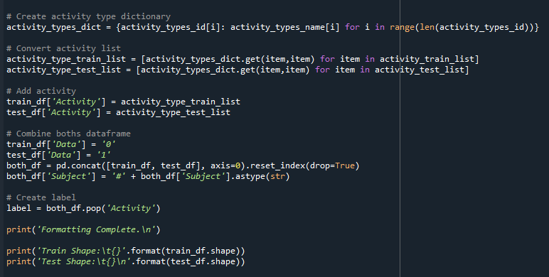

Console Output
The screenshot below shows the output of this section of code.
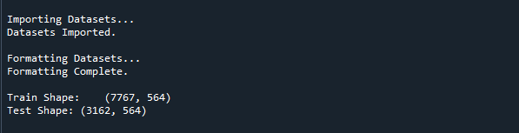
Output as expected, detailing the current process update and the shape of the train and test datasets.

Dataset Exploration
This section of code is for dataset exploration. Initially, a pandas data frame is printed to the console detailing the features grouped by the main names. This is done by using the pandas .from_dict() method to construct the data frame and passing in a counter container that keeps track of how many times equivalent values are added, along with the .split() function to split each of the features by punctuation leaving only the main feature names to be counted, sorted by the frequency and the displayed to the user. Next, the number of null values in the data frame is checked and printed to the console using the data frame method .isna() to detect the number of missing values, this is then printed to the console. After that, a concise summary of the data frame containing both the train and test set is printed to the console using the .info() method.
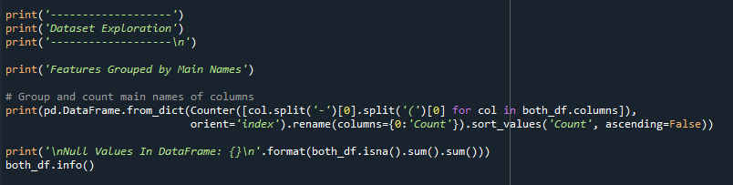
The final block of code in this section is used for creating the smartphone activity distribution plot, this begins by storing .value_count() of the activity labels for each data entry. After the number of entries in label_counts are stored in n and obtained by using the .shape function to return the shape of the array. The matplotlib library is then used to access the ‘Viridis’ colour map, is this a sequential colour map representing the change in lightness and often saturation of colour incrementally, often using a single hue; it is commonly used for representing information that has order. The n value and colourmap are then used to create a list of the colours used in the plot.
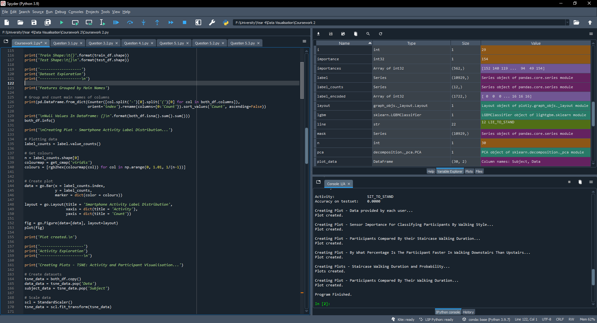
Using the Plotly library for the plot, the label_counts data is passed into a bar chart with the colours being used as the markers and the title and axis labels are set accordingly. Finally, the plot is created and can be shown.

Console Output
The screenshot below shows the output of this section of code.
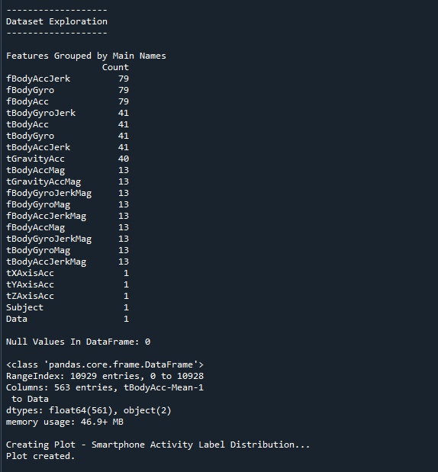
Output as expected, printing the frequency of the main features. Mostly there are 'acceleration' and 'gyroscope' features along with a few 'gravity' features too. Next, the number of null values check shows there are no missing values and the data frame information shows the dataset with the added ‘Data’ and ‘Subject’ features. Finally, the creating update of the smartphone activity label distribution plot is shown.

Plot
This plot shows the distribution of smartphone activity labels.
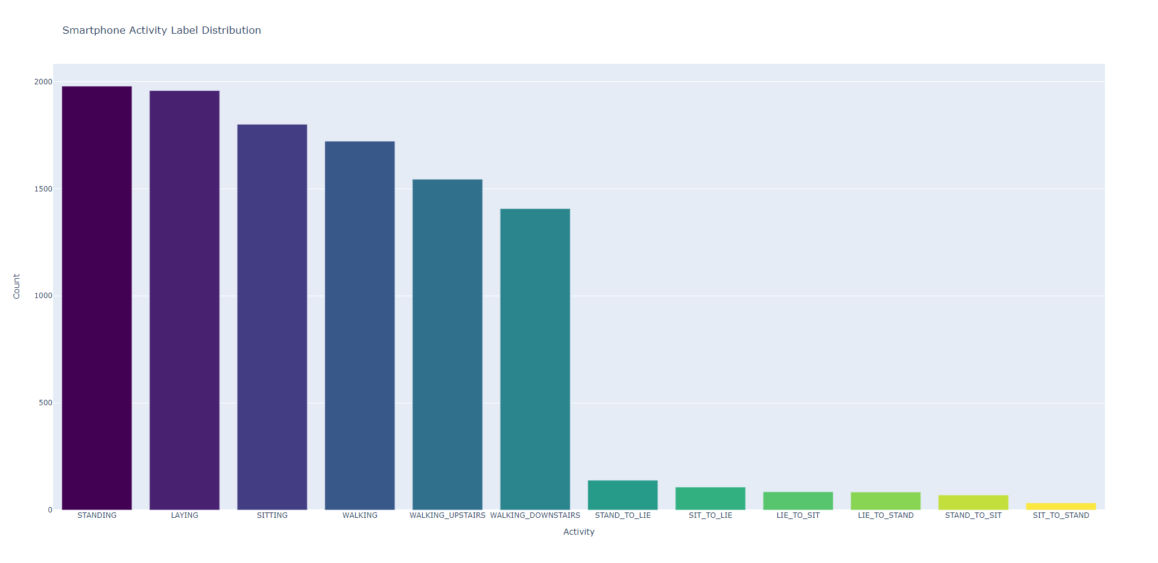
The plot shows that 6 activities were significantly more frequent than the others. Within each group of 6, the plot shows fluctuations in the frequency of the activity though each group is distributed relatively equally. Under the assumption that each participant had to make the same number of trips upstairs as downwards, the smartphone had a constant sampling rate, and the data is not flawed there should be the same amount of data points for walking upstairs as there is downstairs. This suggests that the participants seeming walking roughly 9% faster downstairs.

Activity Exploration
This section of code is for the activity exploration. The first part of this code is used for creating the TSNE: Activity and Participant Visualisations. Since this is created using the PCA and T-SNE methods to reduce the dimensions in the data, the data needed to be handled differently and therefore formatted differently. Initially, a copy of both_df is made and stored in tsne_data. From tsne_data, the ‘Data’ and ‘Subject’ columns were removed using the .pop() method and stored in data_data and subject_data respectively. The tsne_data is then scaled using the sklearn StandardScaler to transform the data. PCA is then applied to the data projecting it into a lower-dimensional subspace before T-SNE is applied minimises the divergence between distributions. Each of these methods of scaling and reduction can be time-consuming since they calculate complex calculations for large datasets. The two plots are created using the Seaborn library, to plot the data points for each of the Activity and Participants visualisations.
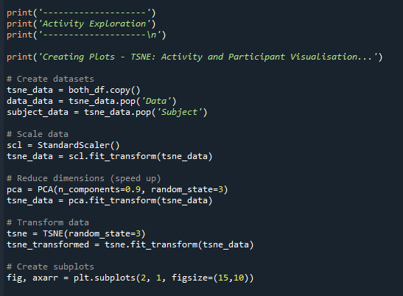

The same method used for obtaining the colours for each activity as shown in the previous section is used once again with a slight change to ‘n’ instead equal the number of unique labels in the label set. Next, for each activity, each data entry is plotted. A mask is applied to easily handle any missing, invalid, or unwanted entries in the dataset, this is precautionary since we have applied several methods of scaling and dimensional reduction to the dataset. For each activity the algorithm iterates the entire dataset therefore, this step can also be time-consuming. Finally, for this plot, the title is set and the .legend() call is made to stop any arguments being passed into the plot. The same method of plotting is then applied to switch the activity for each participant by using subject_data instead of the labels.
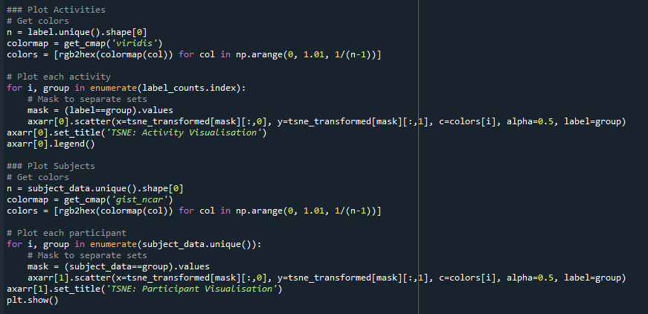
To test the separability of the data, the data must be accurate. This was done using an LGBM classifier. First, a sklearn LabelEncoder is declared to transform the label before being used for classification. Using the sklearn train_test_split to generate a train and test dataset and label set based on the tsne_data before declaring the LGBMclassifier with 500 estimators and 3 random states, these values were selected as an average for a dataset of this size and considering this is an exploration to prove general accuracy of the dataset no fine-tuning is required. The train set and labels are then used to fit the model. Finally, the test set is used to get the model to predict and calculate the accuracy. This is done using the lgbm.predict() and sklearn accuracy_score() methods.
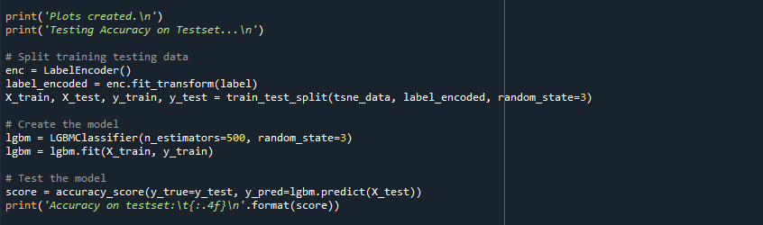

Console Output
The screenshot below shows the output of this section of code.
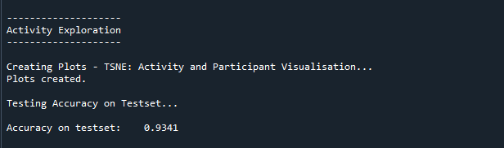
Output as expected, printing creating TSNE: Activity and Participant plot update and the accuracy of the test set. The accuracy shows that with a simple untuned model, the activity of the smartphone user can be predicted with an accuracy of 93%.

Plots
These plots show the separability of the activity classes and the participants.
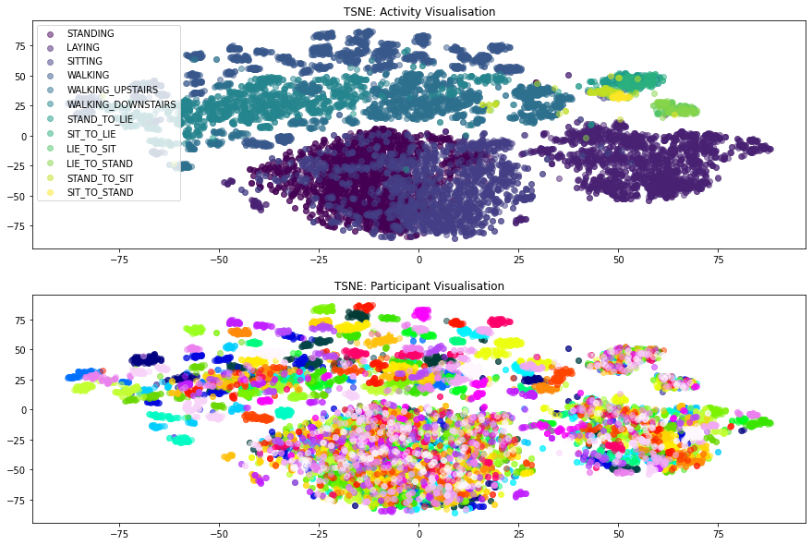
The activity visualisation shows that each of the activities is most separable from each other through similar activities tend to become slightly plot together. The participant visualisation reveals the personal data of each participant showing that everybody has a separable walking style (on the upper-middle and upper-left of the plot), this suggests that a smartphone should be able to detect both the activity and the participant, in layman’s terms what you are doing and also who is using the smartphone.

Participant Exploration
This section of code is for participant exploration. As we notice in the previous section the separability of the participants seems to vary regarding their activity. To find figure out if the participants are separable, further investigation was required by using the same simple data for each activity separately. A for loop was used for each activity passing only the data for the activity into the model using the same methods as before. Additionally, the result is also stored in the variable ‘data’.
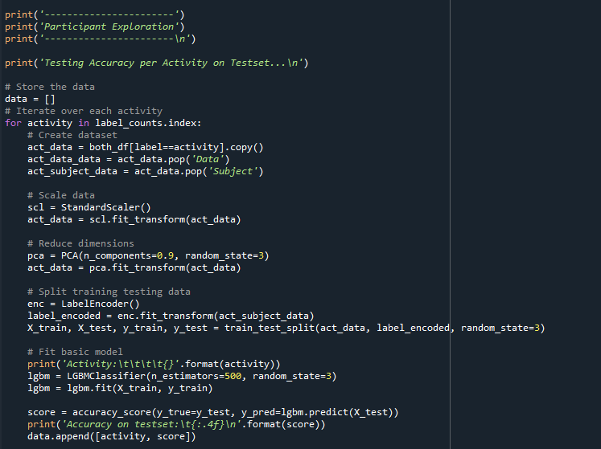
Each of the remaining screenshots shows a different plot being created. The first one used a Seaborn count and target the ‘Subject’ as the x parameter to show the data provided by each user.
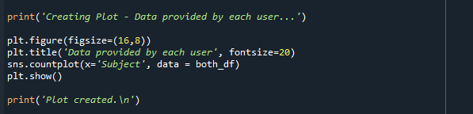

The following code segment is used to plot the sensor importance for classifying participants by walking style by using the same simple model method as seen before. The importance of each sensor is obtained by getting the features from the data frame feature_importances from the lgbm model. Then using a for loop to calculate the sum of the importances and a simple if statement to increment the data count if ‘Gyro’ and ‘Acc’ are within the importance. Finally, using the data and data frame and the from_dict() method to create sensor_df which is then plotted.
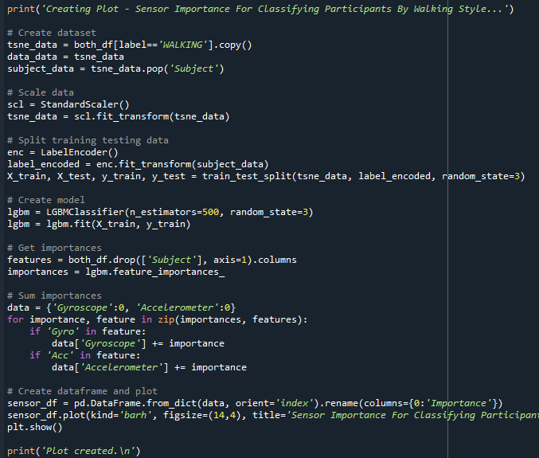

Next shows the code segment used to plot the participants compared by their staircase walking duration. Initially, a mask is created to only get the walking_upstairs and walking_downstairs labels. This is then applied to the both_df, by getting the count of the data grouped by the subjects and then multiplied by 1.28 since the description of the data states that for each single data point a ‘fixed-width sliding windows of 2.56 sec and 50% overlap’ meaning that a datapoint is gathered every 1.8 secs. The plot data is then created by sorting the values of the duration_df to largest first and then mapping the ‘Activity’ column to ‘Upstairs’ and ‘Downstairs’ to reduce the number of words on the plot since these can be interpreted. Finally, a Seaborn bar plot is used passing the data as the plot data, the x parameter as ‘Subject’ since this plot is comparing the participants, the y parameter as ‘Data’ to show the previously calculated duration, and finally applying a hue of the activity.
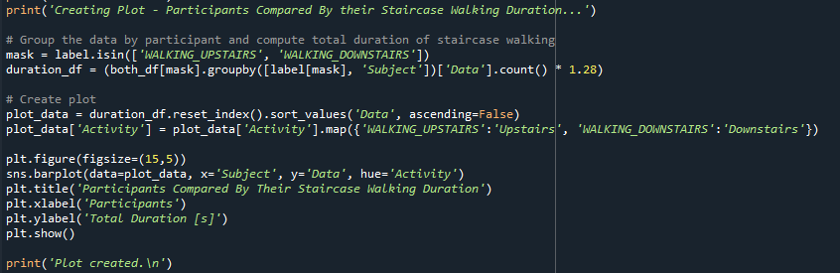
Following the previous segment, the next screenshot shows the method for plotting by what percentage is the participants faster in walking downstairs rather than upstairs. This uses the same duration_df to locate the walking_upstairs and walking_downstairs activities by inside dividing the result of the walking_upstairs by the walking_downstairs and taking away 1 to create the data as a percentage. Finally, the values are sorted and then plot according to the plot data index and plot data.
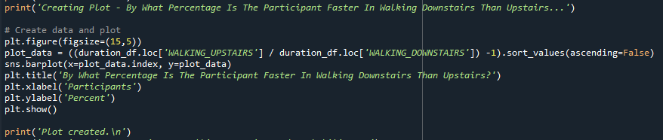

To assure there are no outliers or trends in the data causing inaccurate results in the staircase walking duration data. The following code segment plots the distribution trend of the staircase walking duration data. Using the Scipy library the data are fit to the norm and stored as ‘mu’ and ‘sigma’ then the skew of the data is calculated and stored as ‘alpha’. A subplot is then created to store each of the plots. A Distplot and a Probplot are used to display the distribution of the data and the probability of the data.
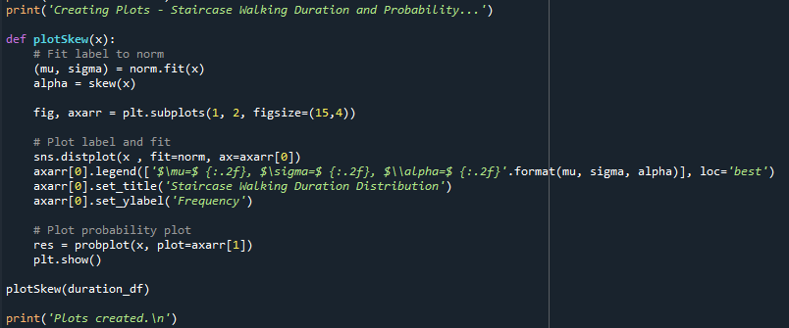
The final segment of code is used to plot the participants compared by their walking duration similar to the earlier section however targeting the total walking duration as a single variable.
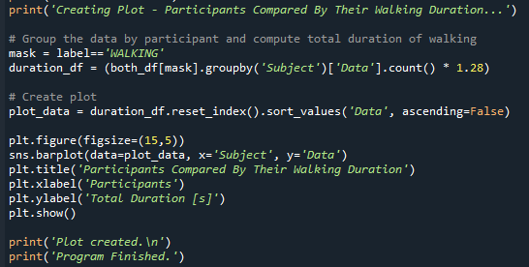

Console Output
The screenshot below shows the output of this section of code.
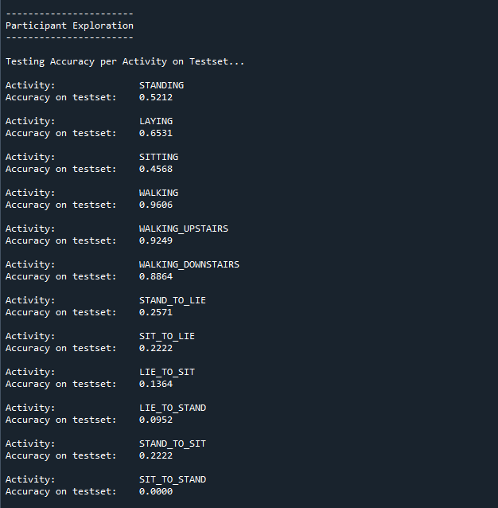
Output as expected, printing the accuracy of each activity on the test set. The accuracy of each activity shows that detecting the current activity of a participant is not entirely possible due to the poorer accuracy of less frequent activities. However, it is highly accurate in comparison to walking with 96%. Walking Upstairs and Walking Downstairs also achieved high accuracy of 92% and 88% respectively. Since higher accuracy is achieved seemingly when the participant moves around implying that a unique walking/movement style can be determined for each person.
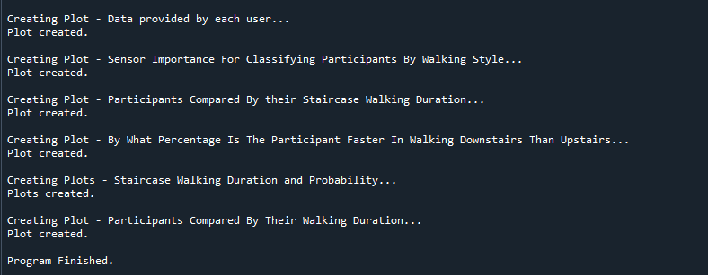
Output as expected, printing each of the creating plot updates.

Plots
This plot shows the data provided by each user.
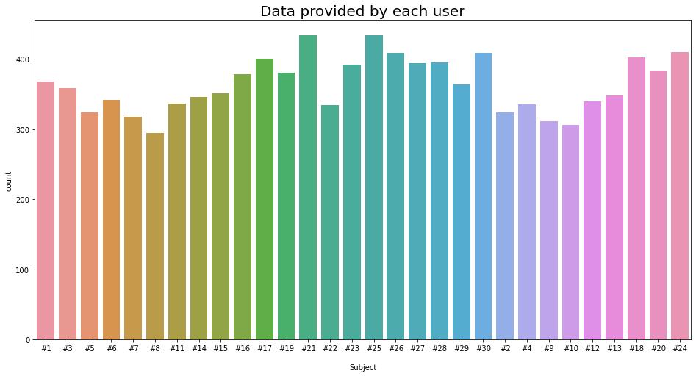
There is an equal distribution of readings from each of the subjects meaning there are not any significant outliers or imbalances in the data to raise concern.
This plot shows the importance of both the accelerometer and gyroscope sensors when classifying participants by walking style.
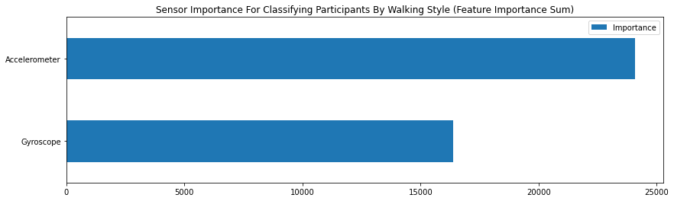
The accelerometer supplies slightly more information though both the sensors are important for the classification and should both be used to assure the quality of the model.

This Plot shows the participants compared by their staircase walking duration.
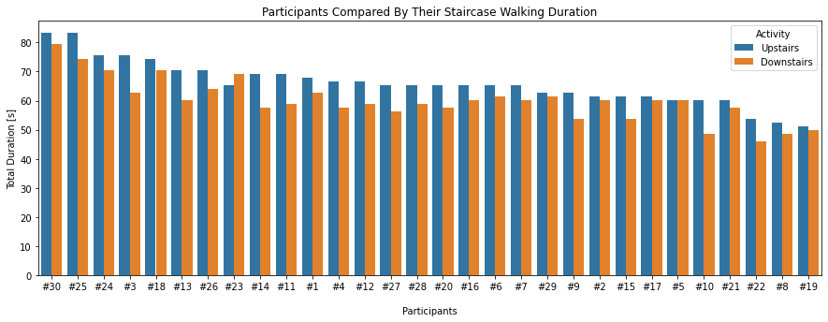
Nearly all the participants provide more data for walking upstairs rather than downstairs. Assuming that the participants walked up and down the stairs an equal number of times, the participants took more time walking upstairs.
This plot shows by what percentage is the participants faster in walking downstairs than upstairs.
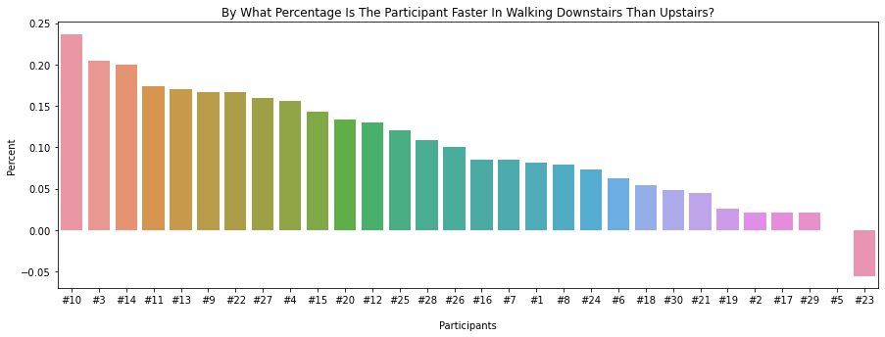
There is a wide variation in percentage difference for each participant. Each value represents an individual's physical condition and speculatively would correlate to the participant's age and health.

These plots show the distribution of the staircase walking duration and probability plots
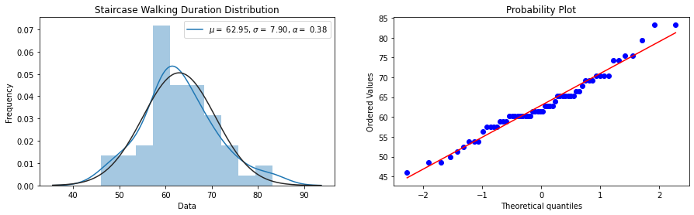
As is the case with most real-world datasets, the duration of walking on the staircase is normally distributed.
This plot shows the comparison of participants based on their walking duration.
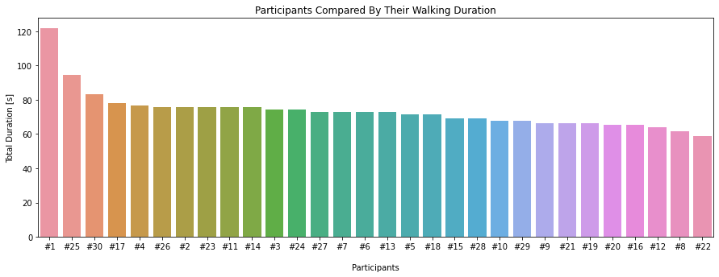
As the duration of each participant is distributed across them, the assumption is that the participants had a fixed walking distance for the experiment rather than a fixed duration.

Evaluation
The data analysis shows that a smartphone has enough data to determine what a user is doing (93%: 12 activities) and even the basics of a person’s specific walking style (Slow steps per second). By linking these insights to more personal data of the participants extensive options open up. In addition, these insights have been extracted from only two sensors which the vast majority of smartphones will have and can most likely be accessed from nearly all applications. In a review of the coursework aims and objectives, the program above shows several methods of manipulating the datasets showing a variety of plots and research exploration to gain an understanding of the data. The practical element of this was challenging at first, especially when initial beginning to manipulate the data followed by implementing PCA and T-SNE. However, through the repetition of the project, manipulating the data and implementing some of the later plots became far less challenging.

References
[1] J.-L. Reyes-Ortiz, L. Oneto, A. SamÃ, X. Parra, and D. Anguita, “UCI Machine Learning Repository: Smartphone-Based Recognition of Human Activities and Postural Transitions Data Set,” Neurocomputing, 2015. http://archive.ics.uci.edu/ml/datasets/Smartphone-Based+Recognition+of+Human+Activities+and+Postural+Transitions (accessed Apr. 21, 2022).
[2] L. Bao and S. S. Intille, “Activity recognition from user-annotated acceleration data,” Lect. Notes Comput. Sci. (including Subser. Lect. Notes Artif. Intell. Lect. Notes Bioinformatics), vol. 3001, pp. 1–17, 2004, doi: 10.1007/978-3-540-24646-6_1.
[3] D. M. Karantonis, M. R. Narayanan, M. Mathie, N. H. Lovell, and B. G. Celler, “Implementation of a real-time human movement classifier using a triaxial accelerometer for ambulatory monitoring,” IEEE Trans. Inf. Technol. Biomed., vol. 10, no. 1, pp. 156–167, Jan. 2006, doi: 10.1109/TITB.2005.856864.
[4] Scikit-learn, “sklearn.decomposition.PCA — scikit-learn 1.0.2 documentation,” 2022. https://scikit-learn.org/stable/modules/generated/sklearn.decomposition.PCA.html?highlight=pca#sklearn.decomposition.PCA (accessed Apr. 22, 2022).
[5] L. Van Der Maaten and G. Hinton, “Visualizing data using t-SNE,” J. Mach. Learn. Res., vol. 9, pp. 2579–2625, 2008.
[6] Scikit-learn, “sklearn.manifold.TSNE — scikit-learn 1.0.2 documentation,” 2022. https://scikit-learn.org/stable/modules/generated/sklearn.manifold.TSNE.html (accessed Apr. 22, 2022).
[7] LightGBM, “Welcome to LightGBM’s documentation! — LightGBM 3.3.2.99 documentation.” https://lightgbm.readthedocs.io/en/latest/index.html (accessed Apr. 22, 2022).

